LUCA
DIY Self-Hosting Installation Guide
From bare server to fully working AI accounts department — step by step
Version 0.5 | github.com/roger296/lucaV0.5 | luca-accountant.com
⚠️ Beta Software
Luca is currently in active development. Instructions in this guide reflect v0.5 and will be updated as the product evolves. For the latest information always refer to the README on GitHub.

Contents

Introduction
This guide walks you through every step needed to self-host Luca on your own server and use it to manage your accounts. — All steps are covered, from provisioning a VPS on Liquid Web through to calling Luca in Claude Co-Work for the first time.
Luca is entirely free and open-source. The only ongoing costs are your server (from around $5/month on Liquid Web) and a Claude Co-Work Pro subscription ($20/month, billed by Anthropic). There are no Luca licence fees although, if you prefer you can have a server set up for you for £20 per month - https://luca-accountant.com/luca-signup/ for more details.

Architecture Overview
Before you begin, it helps to understand what you are building. The system has three main parts running in two locations:

Your VPS | Runs the Luca General Ledger API (Node.js/Docker), PostgreSQL database, Merkle Chain audit files, nginx reverse proxy, and the MCP server that Claude connects to.
Your Computer | Runs the Claude desktop app (Co-Work mode) with the Luca Skills installed. Claude communicates with the VPS over an encrypted HTTPS link through the internet.
Anthropic Cloud | Provides the Claude AI reasoning engine via the Co-Work Pro subscription. No financial data is stored by Anthropic — only the AI conversation context.

🔒 Your Data Stays on Your Server
All financial data — journal entries, bank transactions, invoices — is stored exclusively on your VPS in PostgreSQL and the Merkle Chain files. The AI layer (Claude Co-Work) only receives structured responses from your MCP tools, not raw database contents.

Part 1 — Provision a Server on Liquid Web
Liquid Web is a premium managed hosting provider with data centres in the US and Europe — known for excellent performance and 24/7 support. Using the link below supports Luca's continued development.

1.2 Create a VPS
This instructions explain how to create a virtual private server (VPS) for simple testing of the Luca system while it is in beta mode. We're focusing here on giving you the easiest option at the lowest cost but if you want to use it in production you may want to upgrade from these specifications to a faster server with backups and management in place.
- At the Liquid Web referral link cart.liquidweb.com/refer-a-friend/574405721575 you should see this page
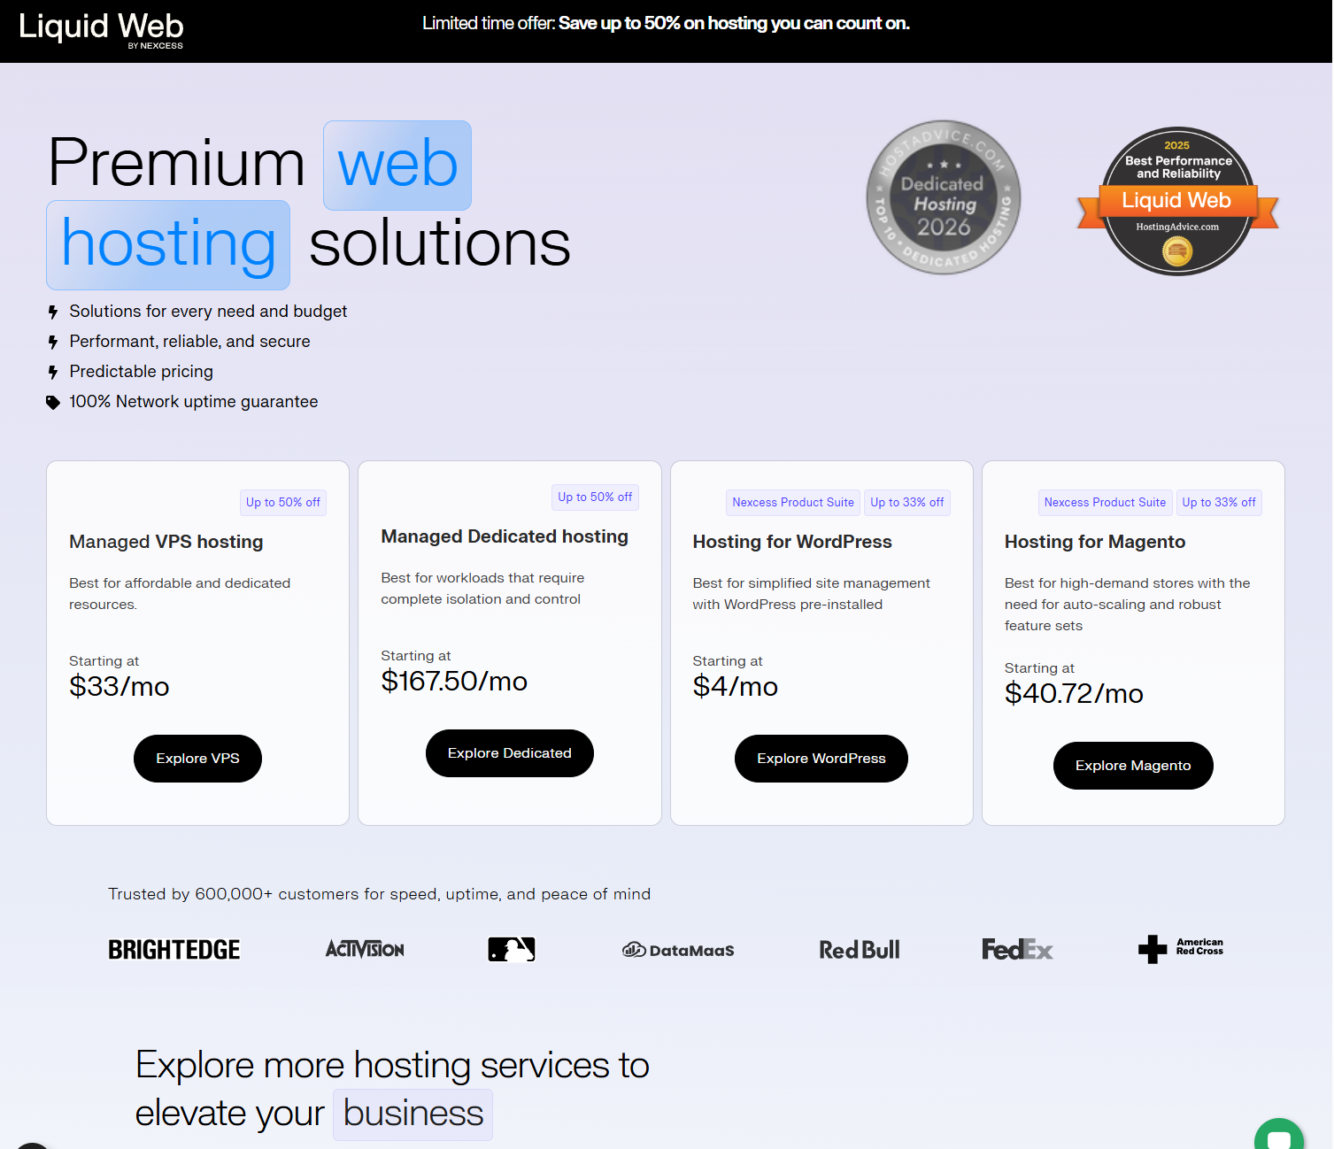
- Create Your VPS. Start by clicking on the "Explore VPS" button under Managed VPS Hosting, Bed switch the choice at the top of the page from managed to self-managed, This should reduce the prices of each of the VPS offered, make sure that Linux is selected above the list of different size VPS service and click ‘Buy now’ on the cheapest option.

💡 Tip — Choose a Data Centre Close to You
Pick a data centre location geographically close to your main office. This reduces latency when Claude Co-Work on your desktop talks to the MCP server. Liquid Web has data centres in multiple locations.
- In the form that comes up you can configure the server that you want to buy first choose the location closest to your physical location, next leave the management option on self-managed for a test server or choose a management option if you are going to be using the product professionally, in the software section select Ubuntu I'd leave the default version which should be 24.04 LTS, You do not need a control panel and you can Use even the smallest specification server for testing, if you prefer a more powerful server feel free to select it. you do not need backups or any further adults for testing but they can be added if you wish.
- You can then decide to pay monthly, yearly or for 2 years service up front, click ‘Add to cart’ and go to the checkout page where you can set up an account and complete the payment in the normal way.
- What's that done you should be redirected to the liquid web user portal, if you are not redirected you can access it at https://portal.liquidweb.com/. Choose ‘My Servers’ from the menu on the left hand side of the page and then click on the listing for the server that you just created to open up the server details page. you can use this page to see information about your server and to edit some parts of it if required.
- Wait 1–2 minutes for the server to Be fully provisioned you know that that's been done when you see a green tick and the word running appear below the server name at the top of the page.

- Note the server's public IP address — you will need it in the next step.

1.3 Point Your Domain at the Server
Luca requires HTTPS and a valid domain name. The automated installer handles the SSL certificate, but your domain must be pointing at the server before you run it.
- Log into your domain registrar's DNS control panel.
- Create an A record pointing your chosen subdomain (e.g. accounts.yourbusiness.com) to the server's IP address. TTL of 300 seconds (5 minutes) is fine.
- Wait for DNS propagation (usually 5–15 minutes). You can check using the command:

nslookup accounts.yourbusiness.com

- Once the IP returned matches your server, proceed to Part 2.

⚠️ Important — Domain Must Resolve Before Running the Installer
The installer requests a free Let's Encrypt SSL certificate automatically. Let's Encrypt needs to be able to reach your domain over the internet. If DNS has not propagated yet, the SSL step will fail. Double-check with nslookup before proceeding.

1.4 Connect to Your Server via SSH
Open a terminal (macOS/Linux) or PowerShell / Windows Terminal (Windows) and connect:
ssh root@<your-server-ip>

Use the primary IP shown on the server details page along with the username and password shown below it under ‘server credentials’ To log into the server over SSH.

Part 2 — Install the Luca General Ledger
The entire installation — Docker, nginx, PostgreSQL, SSL certificate, systemd service — is handled by a single installer script. On a fresh Ubuntu 24.04 server it typically takes 5–10 minutes.

2.1 Run the One-Command Installer
From your SSH session, run:

curl -sSL https://raw.githubusercontent.com/roger296/luca-general-ledger/main/install.sh \
-o /tmp/luca-install.sh && sudo bash /tmp/luca-install.sh

The script downloads first and then runs — this is intentional. Piping directly to bash would prevent the interactive prompts from working correctly.

💡 What the Installer Does Automatically
Installs Docker, Docker Compose, nginx and certbot • Builds and starts the Luca API and PostgreSQL containers • Obtains a free Let's Encrypt TLS certificate for your domain • Generates cryptographically secure random secrets for JWT signing and the database • Configures a systemd service so Luca restarts automatically after a reboot

2.2 Answer the Installer Prompts
The installer will ask you a small number of questions:

Company name | Your business name — displayed in the Luca admin UI (e.g. "Acme Ltd")
Domain | The full domain you set up in step 1.3 (e.g. accounts.yourbusiness.com)
Admin email | Your email address — used for the initial admin account and SSL renewal alerts
Admin password | Choose a strong password for the Luca admin account (12+ characters, mix of types)

⚠️ Save Your Admin Credentials
Write down your admin email and password now. You will need them to generate the Claude Co-Work credentials in Part 5. If you lose the admin password you can reset it from the server command line, but it adds unnecessary steps.

2.3 Verify the Installation
When the installer finishes you should see a success message. Verify the system is running:

# Check container status — all should be "Up"
docker compose ps

# Check the GL API is responding
curl -s https://your-domain/api/health | python3 -m json.tool

You should receive a JSON response containing {"status": "ok"}. If not, check the logs:

# View API logs
docker compose logs api --tail=50

# View all service logs
docker compose logs --tail=20

You can also open https://your-domain in your browser. You should see the Luca login page. Sign in with the admin email and password you set during installation.

Part 3 — Set Up Claude Co-Work
Luca runs inside Claude Co-Work — Anthropic's agentic AI desktop application. You must have an active Claude Co-Work Pro subscription ($20/month) to use Luca.

3.1 Subscribe to Claude Co-Work Pro
- Go to claude.ai and sign up or sign in to your Anthropic account.
- Upgrade to the Pro plan ($20/month). This subscription is billed directly by Anthropic and is separate from any Luca hosting costs.
- Note your Anthropic account email — you will use it to sign in to the Claude desktop app.

3.2 Download and Install the Claude Desktop App
Claude Co-Work is delivered through the Claude desktop application:

- Visit claude.ai/download and download the installer for your operating system.
- macOS: Open the downloaded .dmg file and drag Claude to your Applications folder.
- Windows: Run the downloaded installer and follow the on-screen steps.
- Launch the Claude app and sign in with your Anthropic account.
- Confirm you can see the Claude interface and that your Pro subscription is active (you will see "Pro" indicated in the account menu).

💡 Co-Work Mode
Claude Co-Work is currently a research preview feature of the Claude desktop app. Make sure you are running the latest version of the app to access Co-Work functionality. Check for updates via the app's menu if you do not see it.

Part 4 — Install the Luca Skills
Luca's intelligence is delivered through Claude Co-Work Skills — structured instruction bundles that tell Claude how to perform accounting tasks. The Skills live in a folder inside your Co-Work workspace.

4.1 Create a Co-Work Workspace Folder
Claude Co-Work works with a folder on your local computer as its workspace. This is where skill files, documents for processing, and outputs will be stored.
- Create a new folder on your computer for your Luca workspace. You can do that through file manager on Windows all through the UI on your Mac or use a command line prompt example:

# macOS / Linux
mkdir -p ~/LucaWorkspace

# Windows (PowerShell)
New-Item -ItemType Directory -Path "$env:USERPROFILE\LucaWorkspace"

- In the Claude desktop app, open Co-Work mode and select this folder as your workspace when prompted. (Or via Settings → Co-Work → Workspace Folder → Browse.)

4.2 Download the Skill Files from GitHub
You need the Skills from the Luca GitHub repository. You can either clone the whole repo or download just the skills folder:
Again you can either do this through the user interface by pointing your web browser to the github repository at https://github.com/roger296/lucaV0.5 Or use a command line prompt.

Option A — Clone the full repository (recommended)
cd ~/LucaWorkspace
git clone https://github.com/roger296/lucaV0.5.git luca-source

Option B — Download the ZIP from GitHub
- Go to github.com/roger296/lucaV0.5 and click the green Code button → Download ZIP.
- Extract the ZIP and note the location of the extracted folder.

⭐ Please Star the Repository!
If you find Luca useful, please click the Star button on the GitHub page. Stars help the project gain visibility, attract contributors, and show Anthropic there is community interest in agentic accounting tools. It takes three seconds and makes a genuine difference.

4.3 Install the Skills into Your Workspace
Copy the skill directories from the repository into the Claude Co-Work skills folder inside your workspace:

# macOS / Linux
mkdir -p ~/LucaWorkspace/.claude/skills
cp -r ~/LucaWorkspace/luca-source/skills/lucas-general-ledger \
~/LucaWorkspace/.claude/skills/
cp -r ~/LucaWorkspace/luca-source/skills/luca-setup \
~/LucaWorkspace/.claude/skills/

# Windows (PowerShell)
New-Item -ItemType Directory -Force -Path "$env:USERPROFILE\LucaWorkspace\.claude\skills"
Copy-Item -Recurse "luca-source\skills\lucas-general-ledger" `
"$env:USERPROFILE\LucaWorkspace\.claude\skills\"
Copy-Item -Recurse "luca-source\skills\luca-setup" `
"$env:USERPROFILE\LucaWorkspace\.claude\skills\"

- Restart the Claude desktop app completely (quit and relaunch) so it picks up the newly installed skills.

💡 Verify Skill Installation
After restarting Claude, open a Co-Work session in your workspace and type: "What skills do you have access to?" Claude should list the lucas-general-ledger and luca-setup skills. If they do not appear, double-check the folder path — the skills must be at .claude/skills/ inside your workspace root.

Part 5 — Connect Claude to Your General Ledger’s Model Context Protocol Server (MCP)
The MCP connector is the communication bridge between Claude Co-Work on your computer and the Luca General Ledger on your VPS. It uses OAuth 2.0 for secure authentication.

5.1 Generate Co-Work Credentials on Your Server
- Open https://your-domain in your browser and sign in with your Luca admin credentials.
- Navigate to Admin → Co-Work Credentials in the sidebar.
- Click + Generate credentials.
- You will receive three values:
- MCP Server URL: https://your-domain/mcp
- Client ID: a string identifier for this Claude instance
- Client Secret: a secret shown once — copy it now and store it safely

⚠️ The Client Secret Is Shown Only Once
The Client Secret cannot be retrieved after you leave this page. If you lose it, regenerate new credentials (the old ones will be invalidated). Store it in a password manager immediately.

5.2 Add the Connector in Claude Co-Work
- Open the Claude desktop app.
- Go to Settings → Customize → Connectors → Add connector.
- Fill in the connector form:

Name | My Luca Ledger (or any name you prefer)
Remote MCP Server URL | https://your-domain/mcp
OAuth Client ID | The Client ID from Step 5.1
OAuth Client Secret | The Client Secret from Step 5.1

- Click
- Connect. Your browser will open the Luca login page for OAuth authorisation.
- Sign in with your Luca admin credentials. Click
- Authorise to grant Claude access to the MCP tools.
- Return to the Claude app. The connector should now show as
- Connected with a green indicator.

5.3 Verify the MCP Connection
In a Co-Work session in your workspace, type:
How many MCP tools do you have access to?

Claude should report that it has access to 50 Luca MCP tools. If it reports zero tools or cannot find the connector, see the troubleshooting section in the Appendix.

Part 6 — Your First Luca Session
With the server running, the Skills installed, and the MCP connector active, you are ready to use Luca. Here is how to wake Luca and run your first accounting operations.

6.1 Waking Luca
Luca activates automatically when you mention accounting-related tasks in a Co-Work session. You can also explicitly wake Luca with the phrase:

Wake Luca

Claude will load the lucas-general-ledger skill and confirm that Luca is active and connected to your General Ledger. You should see a response summarising the current state of your ledger.

6.2 Initial Setup — Chart of Accounts
If this is a fresh installation, start by reviewing and configuring your Chart of Accounts:

Show me the current Chart of Accounts

Luca ships with a UK SME default Chart of Accounts. You can ask Luca to add, modify, or remove accounts to match your business structure:

Add a new expense account called "AWS Infrastructure" under code 7200
Rename account 4000 to "Online Sales Revenue"

6.3 Example Commands to Try
Here are some example conversational commands to explore Luca's capabilities:

Financial Reports
Show me the Profit and Loss for this month
What is the current balance sheet?
Who are my top 5 overdue debtors?
What is our VAT position for Q1?

Posting Transactions
Post a purchase invoice from Acme Ltd for £450 + VAT, dated today, for office supplies
Record a payment received from Johnson & Co for £2,340 against invoice INV-0042
Post a bank transfer of £5,000 from current account to savings account

Bank Reconciliation
Start a bank reconciliation for the current account
Import this bank statement and match any transactions you can

Part 7 — Document Inbox and Scheduled Tasks
Luca can process financial documents — invoices, receipts, bank statements, credit notes — automatically. Set up a watched folder and Luca will classify and post them without you having to describe each one manually.

7.1 Create Your Document Inbox Folder
Create a dedicated folder inside your workspace for incoming documents:

# macOS / Linux
mkdir -p ~/LucaWorkspace/inbox
mkdir -p ~/LucaWorkspace/inbox/processed

# Windows (PowerShell)
New-Item -ItemType Directory -Force -Path "$env:USERPROFILE\LucaWorkspace\inbox"
New-Item -ItemType Directory -Force -Path "$env:USERPROFILE\LucaWorkspace\inbox\processed"

The inbox/ folder is where you drop documents for processing. The inbox/processed/ folder is where Luca moves documents after it has handled them.

7.2 Process Documents Manually
To process documents immediately, drop the files into the inbox folder, then tell Luca in a Co-Work session:

Process all documents in my inbox

# Or for a specific file:
Post this invoice to the ledger (with the file attached or the path given)

The gl-document-posting skill will activate automatically. It reads each document, identifies the type (invoice, receipt, credit note, bank statement, etc.), extracts the key fields, determines the correct accounting treatment, and posts the journal entry to the General Ledger.

💡 Supported Document Formats
Luca can process PDF invoices and receipts, CSV bank statement exports, and OFX/MT940 bank feeds. Drag and drop files directly into the Co-Work chat window, or place them in the inbox folder and ask Luca to process it.

7.3 Set Up a Scheduled Batch Task
For fully automated daily processing, configure a scheduled task in Claude Co-Work. This will run Luca's batch processing routine automatically — importing bank feeds, reconciling transactions, preparing VAT figures, and generating an exception report — without any manual intervention.

Step 1 Open the Schedule skill in a Co-Work session
Set up a scheduled task for Luca's nightly batch processing

Step 2 Configure the schedule
Claude will guide you through setting up the task. Specify:
- Schedule: Daily at 02:00 (runs while you sleep)
- Task: Run Luca's nightly batch — reconcile bank feeds, process inbox documents, prepare VAT data, generate exception report
- Workspace: Your LucaWorkspace folder

Step 3 Verify the scheduled task
Once configured, you can trigger a test run immediately:
Run the Luca batch now

Luca will process any documents in the inbox, attempt to match bank statement lines against ledger entries, compute any FX revaluation adjustments, and produce a summary of what it did and what needs your attention.

📋 What the Nightly Batch Does
Imports and processes any documents in the inbox • Runs bank reconciliation and auto-matches high-confidence transactions • Flags low-confidence matches for your review • Computes FX revaluation adjustments if you have multi-currency transactions • Updates the aged debtor and creditor reports • Prepares any outstanding VAT data • Sends you a summary of exceptions that need a decision

7.4 Morning Briefing
Once the nightly batch has run, ask Luca for a morning briefing:
Wake Luca
Give me a morning briefing

Luca will summarise what happened overnight, what was reconciled automatically, and what needs your attention today — giving you a CFO-level view of your financial position in under a minute.

Appendix — Troubleshooting

A.1 MCP Connector Shows "Not Connected"
- Verify the GL API is running: ssh to your server and run docker compose ps — all services should show "Up".
- Check the /mcp endpoint directly: curl https://your-domain/mcp should return a JSON-RPC response.
- Restart the API containers: docker compose up -d --build
- In Claude, disconnect and reconnect the connector — the OAuth token may have expired.

A.2 "Invalid Client" Error During OAuth
- The credentials may have been regenerated on the server. Go to Admin → Co-Work Credentials and generate a fresh set.
- Re-enter the new Client ID and Client Secret in Claude's connector settings.

A.3 Claude Cannot See the Skills
- Make sure the skills are in .claude/skills/ inside your workspace root — not in a subfolder of a subfolder.
- Fully quit and relaunch the Claude desktop app after copying skills.
- In a Co-Work session, type: "What skills do you have?" — skills must be listed for them to be active.

A.4 Installer Fails at SSL Certificate Step
- DNS has not propagated yet. Run nslookup your-domain and confirm it returns your server IP.
- Port 80 must be open on the server for Let's Encrypt HTTP-01 challenge. Check Liquid Web firewall rules.
- Re-run the installer after DNS is confirmed: sudo bash /tmp/luca-install.sh

A.5 Server Management Commands
Useful commands to run from your SSH session:

# Check all containers are running
docker compose ps

# View recent API logs
docker compose logs api --tail=50 -f

# Restart all services
docker compose restart

# Full rebuild (after a Luca update)
git pull && docker compose up -d --build

# Check disk space (chain files grow over time)
df -h

# Verify Merkle chain integrity
# (ask Luca: "Verify the chain integrity")

A.6 Updating Luca
To update to the latest version of Luca on your server:

cd /opt/luca # or wherever the installer placed the files
git pull origin main
docker compose up -d --build
docker compose exec api npm run migrate

💡 Check Release Notes Before Updating
Always review the release notes on GitHub before updating in a production context. Luca is beta software and updates may include breaking changes. The release notes are at github.com/roger296/lucaV0.5/releases.

A.7 Getting Help
If you are stuck, there are several ways to get help:

GitHub Issues | github.com/roger296/lucaV0.5/issues — for bugs and technical questions
Contact eTail Support | sales@etailsupport.com — +44 1227 39 0441
Customisation | luca-accountant.com/luca-signup/ — custom packages from £500
Security issues | security@lucaledger.com — for responsible vulnerability disclosure

Luca is free, open-source software released under the MIT licence. Source: github.com/roger296/lucaV0.5 | luca-accountant.com

